**StreamReader**

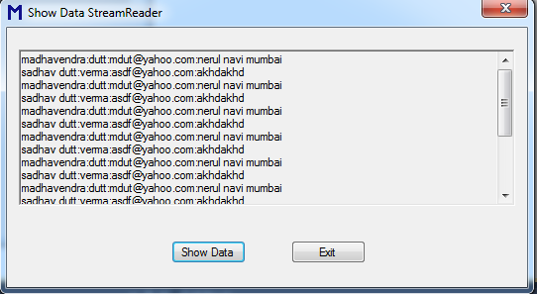

Imports System.IO

Public Class StreamReaderClass

Private Sub btnExit_Click(ByVal sender As System.Object, ByVal e As System.EventArgs) Handles btnExit.Click

Me.Dispose()

Me.Close()

End Sub

Private Sub btnShowData_Click(ByVal sender As System.Object, ByVal e As System.EventArgs) Handles btnShowData.Click

Dim fs As FileStream = Nothing

Dim streamReader As StreamReader = Nothing

Try

fs = New FileStream("D:\TextData", FileMode.Open, FileAccess.Read)

streamReader = New StreamReader(fs)

RichTextBox1.Text = streamReader.ReadToEnd

Catch ex As IOException

MsgBox(ex.Message, MsgBoxStyle.Critical, ex.GetType.ToString)

Finally

If streamReader IsNot Nothing Then

streamReader.Close()

End If

End Try

End Sub

End Class